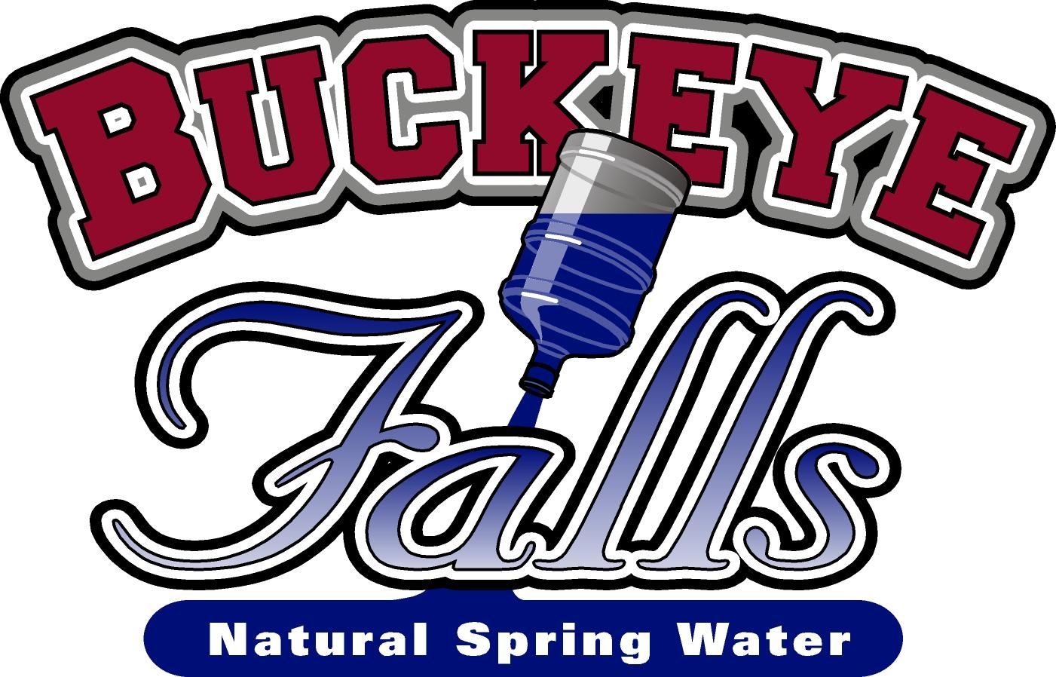
409 N. Main Street, Gibsonburg, OH
419-637-3001

HOURS
9:00 AM – 5:00 PM Monday – Friday
9:00 AM – 12:00 PM Saturday

www.buckeyefallswater.com

Available K-Cups (24 count packages)
Dark | Black Silk | $13.50
Dark | Dark Magic | $13.50
Dark | Double Diamond | $13.50
Dark | French Roast Category 5 | $13.00
Dark | French Roast | $13.50
Dark | Italian Tully’s | $13.50
Dark | Mahogany | $13.50
Dark | No Surrender | $13.50
Dark | Redwood Roast (Guy Fieri) | $13.00
Dark | Sumatran Reserve | $13.50
Flavored | Butter Toffee Gloria Jean | $13.50
Flavored | Buttery Caramel (Folgers) | $13.50
Flavored | Caramel | $13.00
Flavored | Caramel Vanilla | $13.50
Flavored | Chocolate Mint | $12.50
Flavored | Cinnabon Cinnamon Roll | $13.50
Flavored | Coconut Fudge | $13.00
Flavored | Hazelnut | $13.50
Flavored | Hazelnut Biscotti | $13.00
Flavored | Hazelnut Cinnamon Roll | $13.00
Flavored | Hot Fudge Brownie | $13.00
Flavored | Maple Pecan (10 count) | $ 6.00
Flavored | Kahlua | $13.50
Flavored | Pumpkin (10 count) | $ 6.00
Flavored | Raspberry Truffle | $13.00
Flavored | Santa’s White Christmas (coconut, caramel, vanilla) | $13.00
Flavored | Snickers | $13.50
Flavored | Southern Pecan | $13.50
Flavored | Turtle Love | $13.50
Flavored | Vanilla DUNKIN (22 ct) | $13.50
Flavored | Vanilla (Folgers) | $13.50
Flavored | Vanilla Hazelnut | $13.00
Flavored | Wild Mountain Blueberry | $13.50

Unflavored | Barnie’s Blend | $12.50
Unflavored | Breakfast in Bed Wolfgang | $13.50
Unflavored | Breakfast Blend | $13.50
Unflavored | Buddy’s Blend | $12.50
Unflavored | Caribou Blend | $13.50
Unflavored | Classis Roast (Folgers) | $13.50
Unflavored | Columbian Green Mountain | $13.50
Unflavored | Columbia El Nino | $13.00
Unflavored | Costa Rican | $13.50
Unflavored | Daybreak (Caribou) | $13.50
Unflavored | Diner Blend | $13.00
Unflavored | Donut Shop | $13.50
Unflavored | Dunkin Donut | $13.50
Unflavored | Eight O’clock | $13.50
Unflavored | Hawaiian | $13.50
Unflavored | Jamaica Me Crazy | $13.50
Unflavored | Krispy Kreme | $13.50
Unflavored | Lake & Lodge | $13.50
Unflavored | Maxwell House (House Blend) | $13.50
Unflavored | Maxwell House Original | $13.50
Unflavored | McCafe | $13.50
Unflavored | Nantucket | $13.50
Unflavored | Newman’s Organic | $13.50
Unflavored | Pike Place | $17.50
Unflavored | Tim Hortons | $14.50
Unflavored | Vermont Country | $13.50

Decaf | Breakfast Blend GM | $13.50
Decaf | Caribou | $13.50
Decaf | Dark Magic | $13.50
Decaf | Donut Shop (12 count) | $ 6.75
Decaf | French Vanilla | $13.50
Decaf | Half Caff (Green Mountain) | $13.50
Decaf | Hazelnut | $13.50
Decaf | McCafe | $13.50
Decaf | Santa’s White Christmas (coconut, caramel, vanilla) | $13.00
Decaf | Tim Hortons (12 countt) | $ 8.00
Decaf | Unleaded (Guy Fieri) | $12.50
Decaf | Vanilla Hazelnut | $12.50

Tea | Chai | $12.50
Tea | English Breakfast | $13.50
Tea | India Spice Chai | $13.50
Tea | Lemon Chamomile | $12.50
Tea | Mandarin Orange | $13.50
Tea | Panfired Green | $12.50
Tea | Sleepy Time | $13.50

Cocoa | Café Escapes Milk Choc | $13.50
Cocoa | Donut Shop Milk Chocolate | $12.50
Cocoa | Swiss Miss Milk Choc (22 count) | $13.50
Café Escapes | Café Mocha 24 count | $13.50
Café Escapes | Chai Latte 24 count | $13.50
Café Escapes | Café Vanilla 10 count | $ 8.00
Gevalia | Frothy Chai Spice Latte 6ct | $ 6.75

CREATE YOUR OWN VARIETY PACK:
select 24 of your choice for just $14.50
(additional charge for Starbucks)

Commercial & Residential Delivery Available
Prices and selection subject to change

